**2016 Sustainability Report**



**Tobo, Sweden Factory**

**Date: 02/10/17**

**“We take our Corporate Social Responsibilities seriously.”**

As a global leader in energy efficient air treatment solutions, we at Munters take our Corporate Social Responsibility seriously. We understand how we impact the world we all live in.

This is why at Munters we work every day to create “Your Perfect Climate”. For our customers we provide products and solutions that reduce their energy consumption. This contributes to the reduction of the world’s emissions.  
  
In our manufacturing we have a sustainable approach, focusing on efficient usage of natural resources, while reducing and recycling our waste. Because at Munters, one of our core values is to think “there is always a better way”.   
  
We have made significant improvements but we pledge to always seek opportunities to improve our products as well as our manufacturing practices.   
  
Munters will continue to be a part of creating a sustainable future for everyone.

    
**John-Peter Leesi**  
CEO, Munters AB

**2016 Objectives & Targets Summary**

**Corporate Objective #1**

Implement or refine an ***Environmental, Health, & Safety Management Program***

**Target:** Refine the current EH&S Program and further integrate it into our daily business management systems.

**Result:**

15 different educations for total 152 employees have been carried out during 2016.

Four different chemical exposure measurements was conducted during the year and showed values well below the limit values according to AFS 2011:18.

Training in reporting accidents and incidents in C2 has been completed and a lot more reporting is being performed.

We have had training in systematic working environment for all managers and safety representatives.

During 2016 we have performed an alcohol and drug test of 10 % of our employees.

Implemented an annual monitoring of the work environment

**Corporate Objective #2**

Drive continuous improvements through a prioritized ***EH&S*** ***Facility Risk-Aspect List***

**Target:** To identify, select and prioritize our EH&S Risk-Aspects and drive risk reduction within each chosen aspect.

Risk reduction shall be measured by the aspect scoring system.

**Result:**

The training in risk analyzes has evolved and risks regarding safety and health are put in to a prio one! Every week we have one hour scheduled time for this process.

Introduction of new EHS-plan with work tasks and critical roles according to law and internal demands.

We have daily pulse meetings were safety is first on the board and we check the status on:  
1) Accidents/incidents

2) Accessibility of safety showers, eyewash   
3) Accessibility of evacuation routes  
4) Storage of flammable goods  
5) Use of PPE

The safety committee has extended the meetings from 6 meetings per year to 11 per year.

New protections equipment such as hearing protection and safety clothes has been implemented.

All thirteen safety inspections have been completed.

**Corporate Objective #3**

Reduce ***TRIR Rate*** by 10% *(e.g. outside medical treatment, lost work days, restricted duty)*

**Target:** Increase reported deviation to reduce our incident rate

**Result:**

Implemented new template for root cause analyzes for serious accidents and repeated incidents

Updated incident report with more categories to improve the work of incidents automatic classification of the type of incident

Marked escape routes in cold storage

New procedures for labeling and storage of chemicals on the rotor lab to reduce the risk of mixup.

Replacement of a fire ladder to a fire stairs

We have an overall plan for reducing accidents and incidents

**Corporate Objective #4**

Reduce ***Energy / Resource Use*** *(e.g. electricity, natural gas, propane, diesel, oil, water*)

**Target:** Reduce electricity and propane use throughout our administration and manufacturing facilities.

**Result:**

During 2016 our new process line has been making multiple tests. This increases the electricity and water consumption.

All electricity to them is water generated electricity (EPD-produced electricity) instead of our old ovens that use propane.

Many handheld tools are powered by compressed air and it leaks and we have preventive maintenance regularly to prevent leakage

Information about energy consumption are being displayed on the TV-screens in the factory

We have got assistance from the consulting company ÅF and they have performed several activities and there are more to come during 2017.

During 2016 we have installed the presence lighting control in different apartments and controlled ventilation.

**Corporate Objective #5**

Reduce **Water** consumption and/or waste of processes or factory *(reduces, reuse, recycle or capture)*

**Target:** Reduce process water use throughout our manufacturing processes.

**Result:**

We have increased the yield in recycling to reuse as much water as possible. We work extensively with the water that runs from the sedimentation should be as clean as possible.

In 2016, it is an operator that is dedicated to manage the site with the support of production and environmental coordinator.

We have improved maintenance and cleaning routines for the waste water treatment plant. The results during the year are very good.

Tierp municipality has come on an inspection visit and they were satisfied with how we manage the plant. A new contract has been agreed upon where we can emit greater volume of water and some conditions on the parameters have been removed.

**Corporate Objective #6**

Reduce ***Non-Recycled*** type waste *(non-recycled wastes, reduce, reuse or recycle)*

**Target:** Reduce hazardous waste and landfill and review recycling of metals

**Result:**

- A filter press for separating sludge from water was installed during the end of 2014 to minimize waste volume and thereby reduce transportation. The project was a success and due to our increase in volume the press works 3 times a day now reducing volume.

- Nesting software was initiated on rotor material (60%) and metal sheet. It is monitored weekly.

- Since we are producing more and still testing new equipment in the new rotor line we are predicting more waste in landfill and hazardous waste.

**Performance Data Summary**

**Environmental Performance Data**

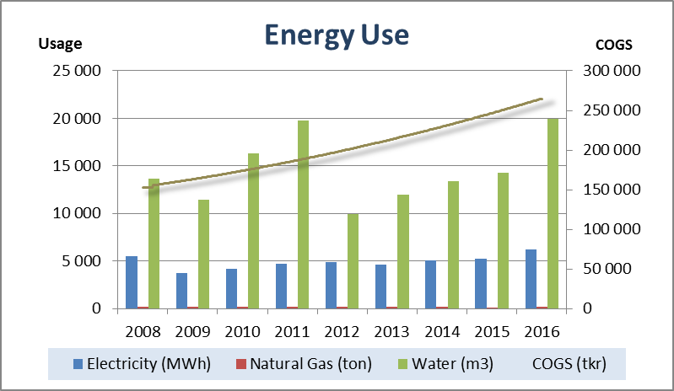

Summary 2016:

* During 2016 our new process line has been making multiple tests. This increases the electricity and water consumption.
* In our new process line new ovens have been installed. All electricity to them is water generated electricity (EPD-produced electricity) instead of our old ovens that use propane
* An energy survey was conducted by the consults ÅF during 2016 and several measures have been implemented

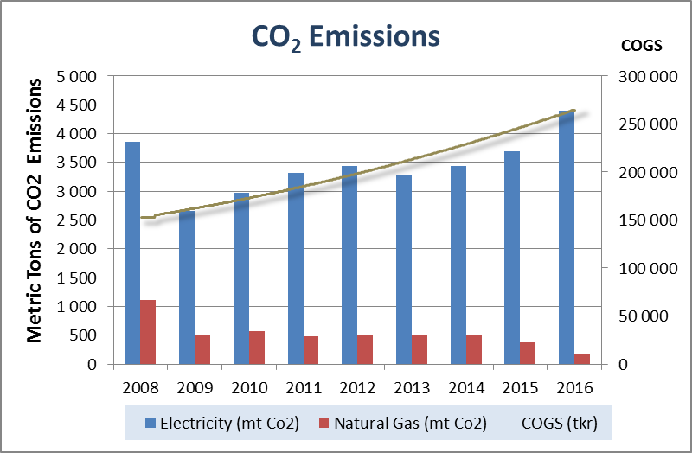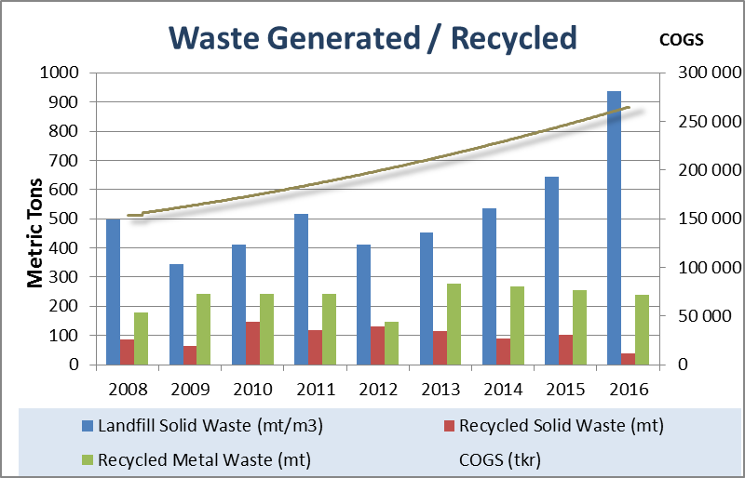

Summary 2016:

* Since we are producing more and still testing new equipment in the new rotor line we have more waste in landfill and hazardous waste. The production volumes are still increasing and focus is to reach production goals not to reduce waste. We are examining some methods to reduce landfill and hazardous waste

**Safety & Health Performance**

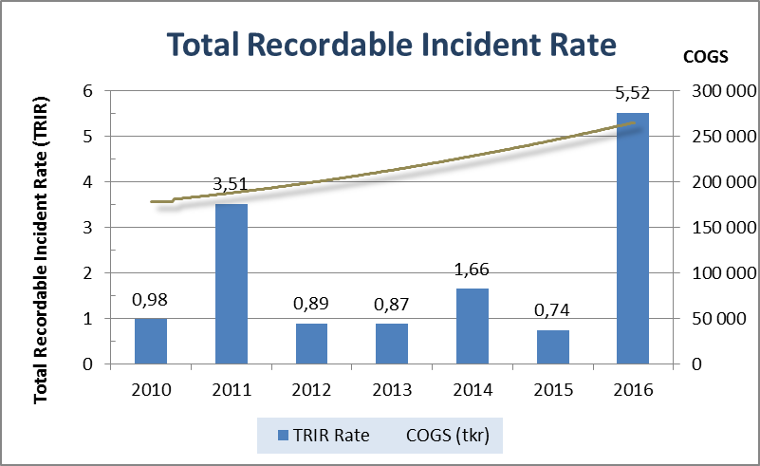

Summary 2016:

* Safety is number 1 on the agenda on every daily target meeting and the reporting in C2 is summarized on the factory target meeting every day.
* We have an overall plan for reducing accidents and incidents
* We have daily pulse meetings were safety is first on the board and we check the status on:  
  1) Accidents/incidents

2) Accessibility of safety showers, eyewash   
3) Accessibility of evacuation routes  
4) Storage of flammable goods  
5) Use of PPE