2016 Sustainability Report

Munters Corporation
Dongguan, Guangdong Factory
Section 8 Jianxing Road, Chashan Town 523380 Dongguan Guangdong China

Date: 02-16-2017

“We take our Corporate Social Responsibilities seriously.”

As a global leader in energy efficient air treatment solutions, we at Munters take our Corporate Social Responsibility seriously. We understand how we impact the world we all live in.
This is why at Munters we work every day to create “Your Perfect Climate”. For our customers we provide products and solutions that reduce their energy consumption. This contributes to the reduction of the world’s emissions.
In our manufacturing we have a sustainable approach, focusing on efficient usage of natural resources, while reducing and recycling our waste. Because at Munters, one of our core values is to think “there is always a better way”.
We have made significant improvements but we pledge to always seek opportunities to improve our products as well as our manufacturing practices.
Munters will continue to be a part of creating a sustainable future for everyone.
John-Peter Leesi
CEO, Munters AB

2016 Objectives & Targets Summary

Corporate Objective #1
Implement or refine an Environmental, Health, & Safety Management Program

Target: Refine the current EH&S Program(s) and further integrate into our daily company business management systems, obtain the certificate of ISO14001 and OHSAS 18001.
Result: Got certificate of ISO14001&OHSAS 18001 by end of 2016.

Corporate Objective #2
Drive continuous improvements through a prioritized EH&S Facility Risk-Aspect List

Target: To assess, select and prioritize our EH&S Risk-Aspects and drive risk reduction within each chosen aspect. Risk reduction shall be measured by the aspect scoring system.

Result: Has accomplished by end of 2016.

Corporate Objective #3
Reduce TRIR Rate by 10% (e.g. outside medical treatment, lost work days, restricted duty)

Target: Reduce our 2016TRIR Rate from 3.41 to 3.07 by improving our injury root cause analysis process and our corrective actions effectiveness, with emphasis on injury trends.

Result: Keep the same level of 2015.

Corporate Objective #4
Reduce Energy / Resource Use by 10% (e.g. electricity , natural gas , propane, diesel, oil, water)

Target: Reduce electricity by machine upgrade to be more energy efficient, improve the machine speed to get more efficient, manage the administration energy use.

Result: 19% in electrity and 21% in natural gas if we based on a single unit product.

Corporate Objective #5
Reduce Water consumption and/or waste of processes or factory by 10% (reduces, reuse, recycle or capture)

Target: Reduce municipal water use by means of improving the water efficiency of plate cleaning and capturing rain water, for use throughout our manufacturing processes.

Result: 31% improvement if we base on a single unit product.

Corporate Objective #6
Reduce Non-Recycled type waste by 5% (non-recycled wastes, reduce, reuse or recycle)

Target: The Non-Recycled waste was major consisting of the leftover material from sawing process and the scraps from the process. We will focus on the material utlization in 2016 to reduce the leftovers and the scraps.

Result: 13.6% was improved if we base on a single unit product.

Performance Data Summary

Environmental Performance Data
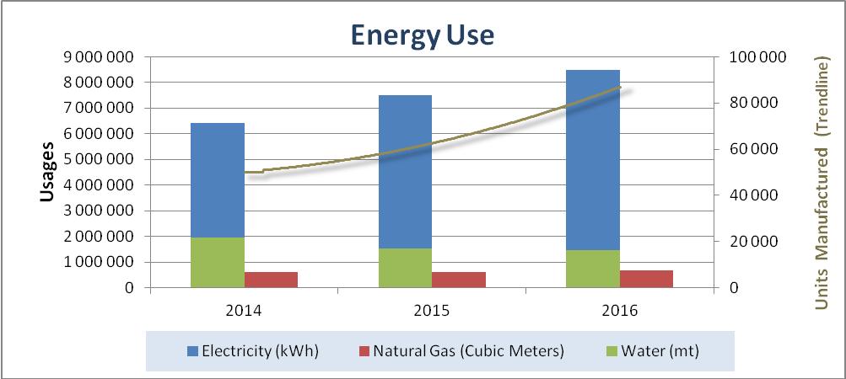

Year | Electricity (kWh) | Natural Gas (m3) | Water (mt) | Volume trendline
2014 | 6425712 | 620000 | 21672 | 50060
2015 | 7510084 | 605000 | 16872 | 62428
2016 | 8497584 | 675000 | 16184 | 86875

Notes:

*The blue and red columns and the aix on the left side represent Natural gas and Electricity consumption. *The green column and the aix on the right side represent water use.
*The trend line and the aix on the right side represent volume produced.

Summary:

Munters Dongguan curtailed
- 19% of unit electricity consumption through efficiency improvement from machine upgrade.
- 20% of unit natural gas consumption through efficiency improvement from machine upgrade.
- 31% of unit water use by since the volume of the dipping pads decrease.

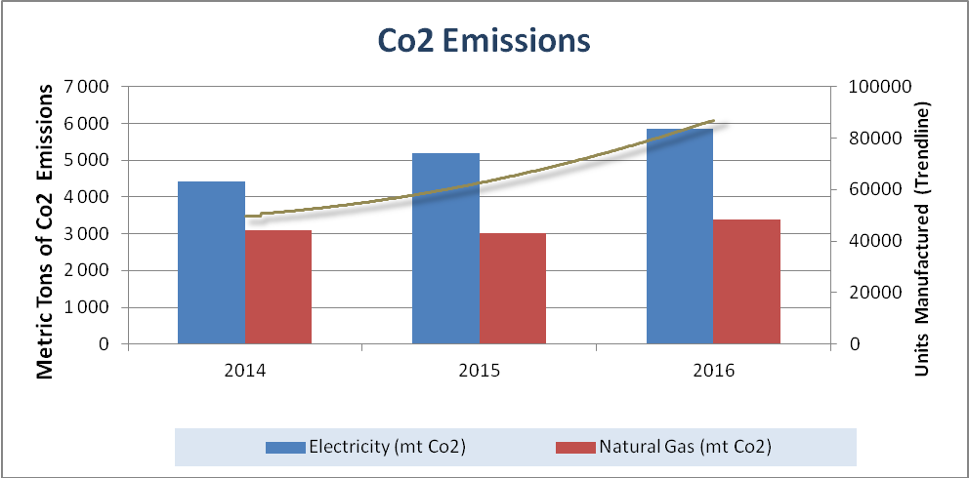

Year | Electricity (mt Co2) | Natural Gas (mt Co2) | Total (mt Co2) | Volume trendline
2014 | 4431 | 3100 | 7531 | 50060
2015 | 5178 | 3025 | 8203 | 62428
2016 | 5859 | 3375 | 9234 | 86875

Notes:

* Trend line represents finish goods / units manufactured
* All emissions calculated through EPA's emission calculators (mt/CO2)
http://www.epa.gov/cleanenergy/energy-resources/calculator.html

Summary:
Munters Dongguan curtailed
- 19% of unit electricity consumption through efficiency improvement from machine upgrade.
- 20% of unit natural gas consumption through efficiency improvement from machine upgrade.

Year | Landfill Solid Waste (mt) | Non-Recycled Solid Waste (mt) | Recycled Solid waste (mt) | Volume trendline
2014 | 1.3 | 75 | 11.84 | 50060
2015 | 1.2 | 87 | 14.15 | 62428
2016 | 1.3 | 105 | 14.36 | 86875

Notes:
* Trend line represents finish goods / units manufactured
* All data is raw, not normalized: therefore increases are due to throughput increases unless otherwise noted

Summary:
90 % of our non-recycled waste (landfill waste) is impregnated paper from the leftovers and the scraps. Munters Dongguan is always improving the material efficiency to reduce the process scrap, and then to reduce the non-recycled waste.
For the recycled solid waste, it consist of carton box, film, paper packing. etc. We are now using the metal pallet to replace the carton box, for the packing of sheets which are sent to our blockformer process.
In 2017 we will try to find a 3rd party to see if some one can recycle this type of waste. E.g. use as a fuel to the heating process.
.

Safety & Health Performance

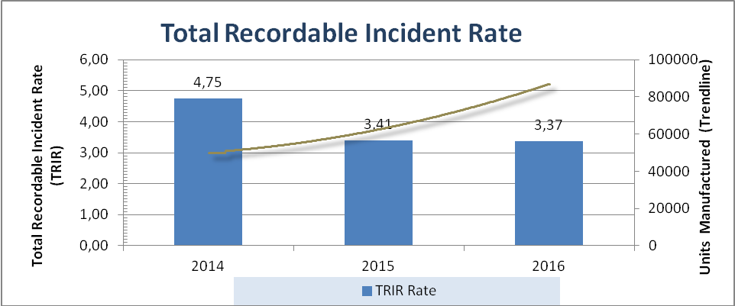

Year | TRIR Rate | Volume trendline
2014 | 4.75 | 50060
2015 | 3.41 | 62428
2016 | 3.37 | 86875

Notes:

* Trend line represents finish goods / units manufactured

Summary:

In 2016 the TRIR is still a downtrend, but we need focus more on this to achieve the 10% improvement.

