2016 Sustainability Report

Munters Corporation
China，JiangYin Factory
No2292 Zhengcheng Road Xishiqiao Jiangying City

Date: 16-02-2016

“We take our Corporate Social Responsibilities seriously.”

As a global leader in energy efficient air treatment solutions, we at Munters take our Corporate Social Responsibility seriously. We understand how we impact the world we all live in.
This is why at Munters we work every day to create “Your Perfect Climate”. For our customers we provide products and solutions that reduce their energy consumption. This contributes to the reduction of the world’s emissions.
In our manufacturing we have a sustainable approach, focusing on efficient usage of natural resources, while reducing and recycling our waste. Because at Munters, one of our core values is to think “there is always a better way”.
We have made significant improvements but we pledge to always seek opportunities to improve our products as well as our manufacturing practices.
Munters will continue to be a part of creating a sustainable future for everyone.
John-Peter Leesi
CEO, Munters AB

2016 Objectives & Targets Summary

Corporate Objective #1 and #2
Implement or refine an Environmental, Health, & Safety Management Program and Drive continuous improvements

Target: Refine the current EH&S Program and further integrate into our daily company business management systems
Result: More detailed EH&S Program are integrated into our daily operation actions, such as working protection guideline and Safety inspection system, more practical EHS actions will be done in future.

Corporate Objective #3
Reduce TRIR Rate by 10% (e.g. outside medical treatment, lost work days, restricted duty)

Target: By improving our injury root cause analysis process and our corrective actions effectiveness, put emphasis on preventing injury trends.
Result: Actual 2016 TRIR Rate was still keeping on a zero level.

Corporate Objective #4
Reduce Energy / Resource Use by 6% (e.g. electricity, natural gas, propane, diesel, oil, water)

Target: Reduce electricity use throughout our administration and manufacturing facilities through curtailment practices, more efficient machinery, and refined lighting and HVAC use.

Result: Energy / Resource Use (especially electricity water)was increased compared with 2015, which caused by business booming in 2016. And Block Former was transferred to Jiangyin Factory since August of 2016.

Corporate Objective #5
Reduce Water consumption and/or waste of processes or factory by 6% (reduces, reuse, recycle or capture)

Target: Reduce municipal water use by means of capturing our HVAC condensation water and capturing rain water, for use throughout our manufacturing processes.

Result: Water consumption and/or waste of processes increased compared with 2015, which caused by business booming in 2016.

Corporate Objective #6
Reduce Non-Recycled type waste by 5% (non-recycled wastes, reduce, reuse or recycle)

Target: Redirect our non-recycled wood waste to a wood recycle center. While further reducing wood waste in conjunction with our suppliers, by use of reusable containers.

Result: Waste of processes increased compared with 2015, which caused by business booming in 2016.

Performance Data Summary

Environmental Performance Data

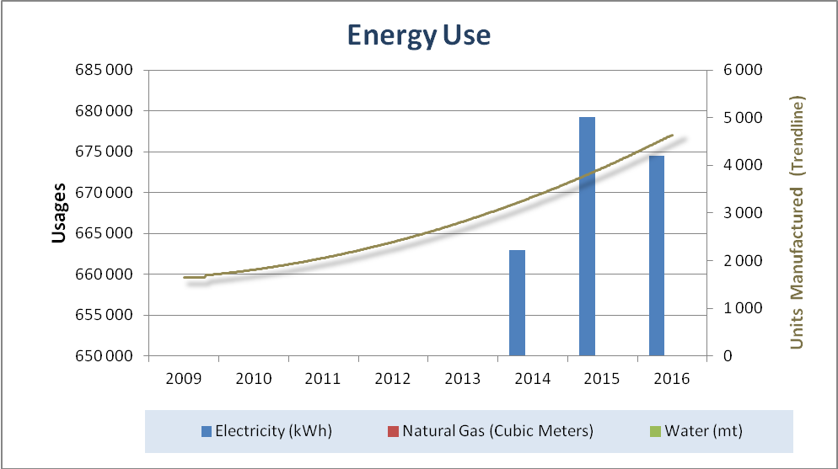
Usage | 2010 | 2011 | 2012 | 2013 | 2014 | 2015 | 2016
Electricity (kWh) | - | - | - | - | 930165 | 662,995 | 674497
Natural Gas (therms) | - | - | - | - | - | - | 3473
Water Usage (mt) | - | - | - | - | 2221 | 3831 | 2840

Notes:
- Trend line represents finish goods/units manufactured
Summary:
1. In August 2016, the Block former machine moved from Beijing to SAT production. After that, Natural Gas began to be used.

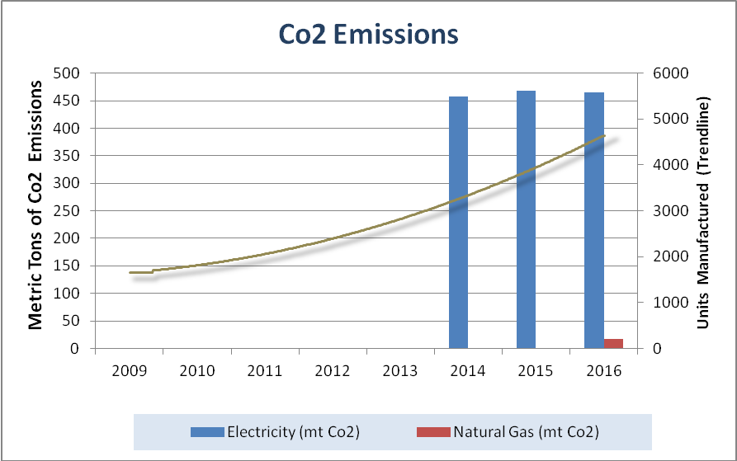
CO2 Emissions | 2010 | 2011 | 2012 | 2013 | 2014 | 2015 | 2016
Electricity (mt) | - | - | - | - | 457 | 468 | 465
Natural Gas (mt) | - | - | - | - | - | - | 17
Total CO2 Emissions (mt) | - | - | - | - | 457 | 468 | 482

Notes:
- Trend line represents finish goods/units manufactured
- All emissions calculated through EPA’s emission calculator (mt/co2) http://www.epa.gov/cleanenergy/energy-resources/calculator.html
Summary:
- We made some rational plan and take actions to better control.
- In August 2016, the Block former machine moved from Beijing to SAT production. After that, Natural Gas began to be used.

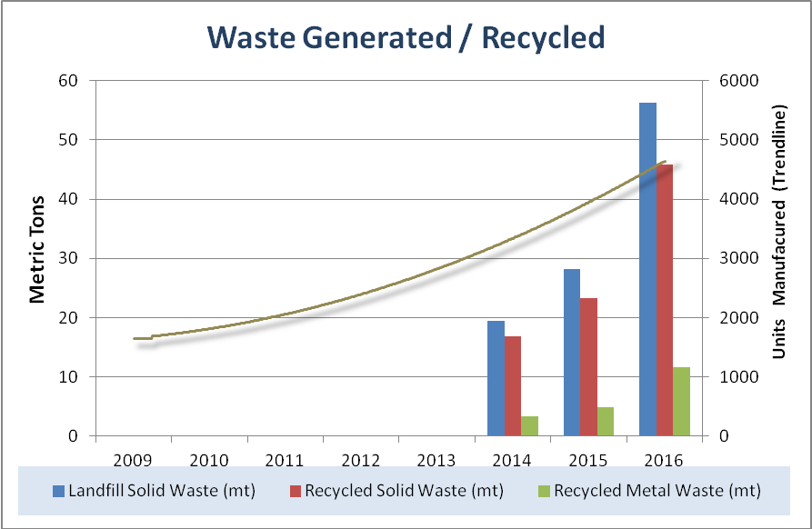

Waste/Recycled | 2010 | 2011 | 2012 | 2013 | 2014 | 2015 | 2016
Solid Waste to Landfill (mt) | - | - | - | - | 19.5 | 28.2 | 56.3
Solid Waste Recycled (mt) | - | - | - | - | 16.8 | 23.3 | 45.9
Metals Recycled (mt) | - | - | - | - | 3.3 | 4.9 | 11.6

Notes:
- Trend line represents finish goods/units manufactured
- All data is raw, not normalized; therefore increases are due to throughput increases unless otherwise noted.
Summary:
- As the quick increase of production volume in 2016, waste/recycled also increased.

Safety & Health Performance
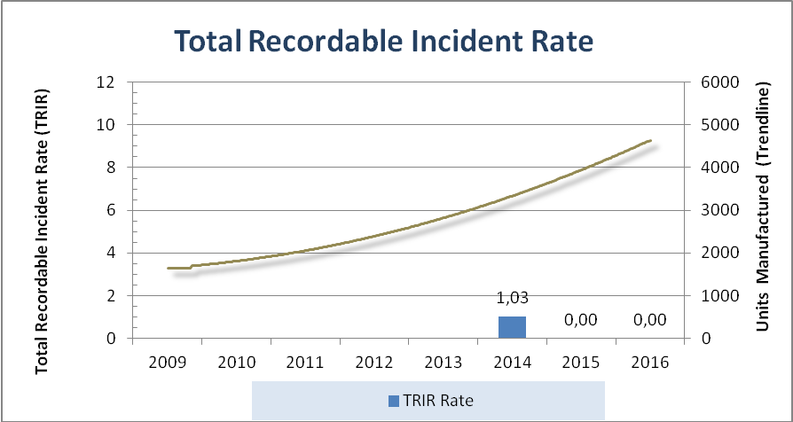

Safety Rates | 2011 | 2012 | 2013 | 2014 | 2015 | 2016
TRIR | - | - | - | 1.03 | 0 | 0

Notes:
- TRIR formula: (Recordable Injuries X 200,000 / Total Labor Hours)
- Trend line represents finish goods / units manufactured.

Summary:
1. TRIR was kept on zero level.

