2016 Sustainability Report

Munters Italy
Italy Factory
18027 Strada Piani 2.
Chiusavecchia (IM) , Italy
&
18026 Strada Piani San Pietro
Pieve di Teco (IM), Italy

Date: 31/12/2016

“We take our Corporate Social Responsibilities seriously.”

As a global leader in energy efficient air treatment solutions, we at Munters take our Corporate Social Responsibility seriously. We understand how we impact the world we all live in.
This is why at Munters we work every day to create “Your Perfect Climate”. For our customers we provide products and solutions that reduce their energy consumption. This contributes to the reduction of the world’s emissions.
In our manufacturing we have a sustainable approach, focusing on efficient usage of natural resources, while reducing and recycling our waste. Because at Munters, one of our core values is to think “there is always a better way”.
We have made significant improvements but we pledge to always seek opportunities to improve our products as well as our manufacturing practices.
Munters will continue to be a part of creating a sustainable future for everyone.
John-Peter Leesi
CEO, Munters AB

2016 Objectives & Targets Summary

Corporate Objective #1
Operation of an Environmental, Health, & Safety Management System

Target: Refine the current EH&S Program(s) and further integrate into our daily business management systems.

Result: Our EH&S Program is now integrated into our daily culture. The obtaining of specific skills by Health & safety team has allowed to perform internal training about EH&S issues.
Training focus about prevention program, reporting and necessary measures has been completed and a lot more reporting and preventive actions are being performed by all departments .
EH&S Surveillance & monitoring plan has been completed step by step by Management Team

Corporate Objective #2
Drive continuous improvements through a prioritized EH&S Facility Risk-Aspect List

Target: To assess, select and prioritize our EH&S Risk-Aspects and drive risk reduction within each chosen aspect. Risk reduction shall be measured by the aspect scoring system.

Result: An upgraded data analysis with graphical description made possible to identify local areas with higher risk on which we focused activities.
In addition we defined critical control points that have to be monitored for each department in order to maintain achieved standards. Any deviations from standards was restored with corrective actions prioritized by Management Team
Daily check about EH&S performance has been properly performed by Department Supervisor.
EH&S internal audit has been carried out as planned and several corrective actions has been followed up leading to a substantial improvement.

Corporate Objective #3
Reduce TRIR Rate by a minimum of 20% annually (e.g. outside medical treatment, lost work days)

Target: Reduce our 2015 TRIR Rate on each site by improving our injury root cause analysis process and our corrective actions effectiveness, with emphasis on injury trends.

Result: Every day subjects relating Health & Safety are the first discussion points on the Operations meeting
Management team together with workers had begun to improve collecting reports about events that’s led to incidents and accidents. We all made efforts to complete corrective action and follow up measures, defined during the investigation. A new template based on PDCA was created to show how the improvements should be consolidated.

Corporate Objective #4
Reduce Energy / Resource Use (e.g. electricity, natural gas, propane, diesel, oil, water)

Target: Reduce energy consumption for lightening shopfloor, implementing new system that’s allow to turn off not-used areas without loss of time or visibility reduction.

Result: We introduced this change, further we will continue step by step substitution of shopfloor lights
with LED ones with low watt requirements, started in 2015.

Corporate Objective #5
Reduce Water consumption and/or waste of processes or factory (reduces, reuse, recycle or capture)

Target: Monitoring water consumption in order to detect any waste

Result: Our water consumption is low and due only to usage inside toilettes and showers, so it
is not possible implement a system for capturing condensation water and capturing rain
water since it could not be used for people. Our production processes don’t require
water usage.

Corporate Objective #6
Reduce Non-Recycled type waste (non-recycled wastes, reduce, reuse or recycle)

Target: Reduce land-fill solid waste and reuse/recycle a portion solid waste

Result: Since the 2016 starts we have implemented a internal recycle of carton box to create filler packaging material. Supplier pallets are always reused on internal production flow for several cycles

Performance Data Summary
(Chiusavecchia)

Environmental Performance Data (Chiusavecchia plant)
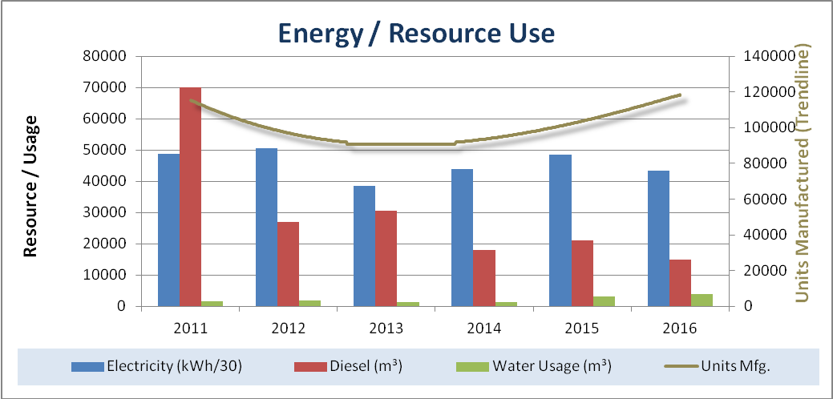

Resource / Usage | 2011 | 2012 | 2013 | 2014 | 2015 | 2016
Electricity (kWh/30) | 48844 | 50647 | 38550 | 43846 | 48520 | 43376
Diesel (m³) | 69920 | 27000 | 30500 | 18000 | 21000 | 15000
Water Usage (m³) | 1727 | 1945 | 1467 | 1394 | 3235 | 3811
Units Manufactured | 111296 | 109653 | 81412 | 86634 | 115354 | 114637

Notes:
* Trend line represents finish goods / units manufactured

Summary:

Changes implemented on the light system allowed us to reduce Electricity consumption during 2016, despite of we introduce new production machinery in Mechanical Department.
Diesel oil consumption necessary to warming system decrease because we moved off-site part of the Office due to restyling started on the buildings

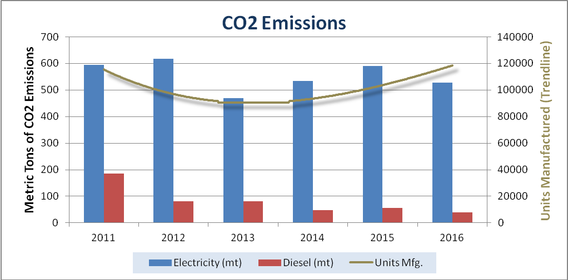

CO2 Emissions | 2011 | 2012 | 2013 | 2014 | 2015 | 2016
Electricity (mt) | 595 | 617 | 470 | 534 | 591 | 528
Diesel (mt) | 185 | 82 | 81 | 48 | 56 | 40
Total CO2 Emissions (mt) | 780 | 699 | 551 | 582 | 647 | 568
Units Manufactured | 111296 | 109653 | 81412 | 86634 | 115354 | 114637

Notes:

* Trend line represents finish goods / units manufactured

* Coefficient taken from IEA’s “CO2 emission from fuel combustion”

Summary:
We have now substitute almost a half part of halogen lamps into production area with low watt requirements LED.
We are continuing to look for new solutions to reduce Electricity consumption, because it is our large contributors of CO2 emissions

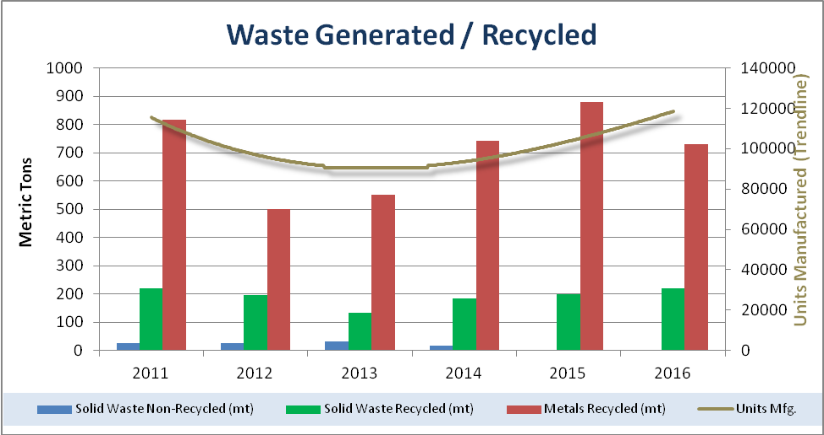

Waste Recycled | 2011 | 2012 | 2013 | 2014 | 2015 | 2016
Solid Waste Non-Recycled (mt) | 24 | 24 | 32 | 17 | 0 | 14
Solid Waste Recycled (mt) | 220 | 195 | 133 | 185 | 199 | 221
Metals Recycled (mt) | 817 | 501 | 552 | 743 | 880 | 731
Units Manufactured | 111296 | 109653 | 81412 | 86634 | 115354 | 114637

Notes:
* Trend line represents finish goods / units manufactured

Summary:
In Chiusavecchia solid waste non recycled portion is formed by Machinery maintenance material and some non-iron scrap
Starting from 2015 we tried to reduce Non-recycled portion, implementing actions to reduce scrap and choosing new maintenance material with same purpose but better recycling
Since the 2016 starts we have implemented a internal recycle of carton box to create filler and reuse it as packaging material. Supplier pallets are always reused on internal production flow for several cycles

Safety & Health Performance (Chiusavecchia plant)

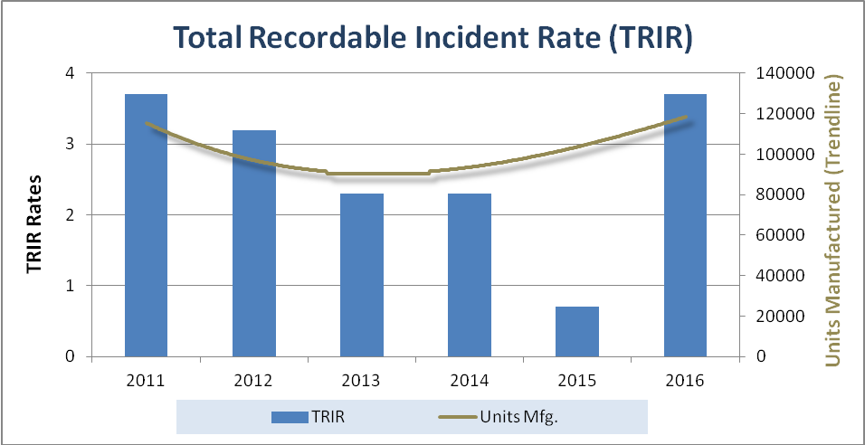
Safety Rates | 2011 | 2012 | 2013 | 2014 | 2015 | 2016
TRIR | 3,7 | 3,2 | 2,3 | 2,3 | 0,7 | 3,7
Units Manufactured | 111296 | 109653 | 81412 | 86634 | 115354 | 114637

Notes:

* Trend line represents finish goods / units manufactured

Summary:
Management team together with workers had begun to improve collecting reports about events that’s led to incidents and accidents. We all made efforts to complete corrective action and follow up measures , defined during the investigation but in spite of these unfortunately during 2016 there was an increase of accidents.
We intend to change direction as soon as possible.

Performance Data Summary
(Pieve di Teco)

Environmental Performance Data (Pieve di Teco plant)

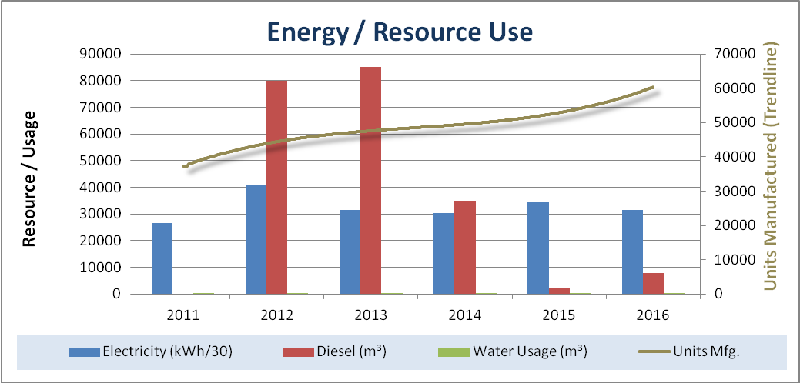
Resource / Usage | 2011 | 2012 | 2013 | 2014 | 2015 | 2016
Electricity (kWh/30) | 26652 | 40592 | 31413 | 30408 | 34336 | 31406
Diesel (m³) | 0 | 80000 | 85000 | 35000 | 2500 | 8000
Water Usage (m³) | 150 | 150 | 150 | 150 | 150 | 150
Units Manufactured | 34419 | 53543 | 40604 | 45328 | 60615 | 57709

Notes:
* Trend line represents finish goods / units manufactured

Summary:
Compared to last year warming system has been modified using diesel heaters in some areas and electric radiant heaters in others. Water use data are not significant because it is calculated on a flat rate

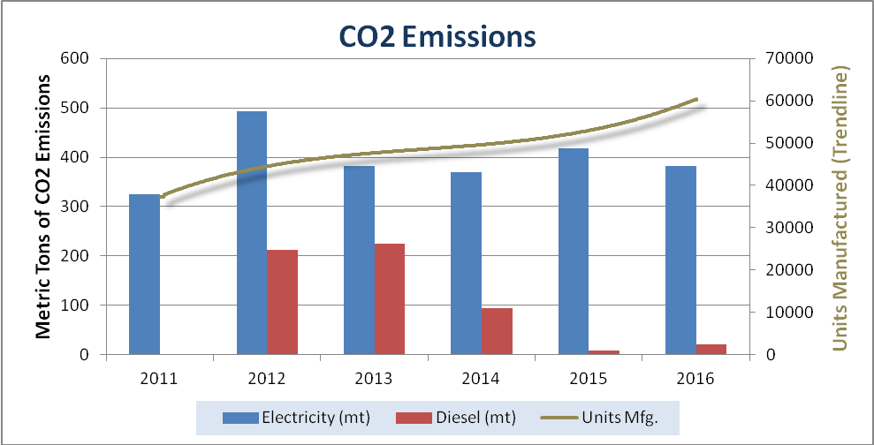

CO2 Emissions | 2011 | 2012 | 2013 | 2014 | 2015 | 2016
Electricity (mt) | 325 | 494 | 383 | 370 | 418 | 383
Diesel (mt) | 0 | 212 | 225 | 93 | 7 | 21
Total CO2 Emissions (mt) | 325 | 706 | 608 | 463 | 425 | 404
Units Manufactured | 34419 | 53543 | 40604 | 45328 | 60615 | 57709

Notes:
* Trend line represents finish goods / units manufactured

* Coefficient taken from IEA’s “CO2 emission from fuel combustion”

Summary:
We implemented changes on the layout in order to try to reduce heat dissipation and the use of artificial lights during the daylight hours.
We are continuing to look for new solutions to reduce Electricity consumption, because it is our large contributors of CO2 emissions

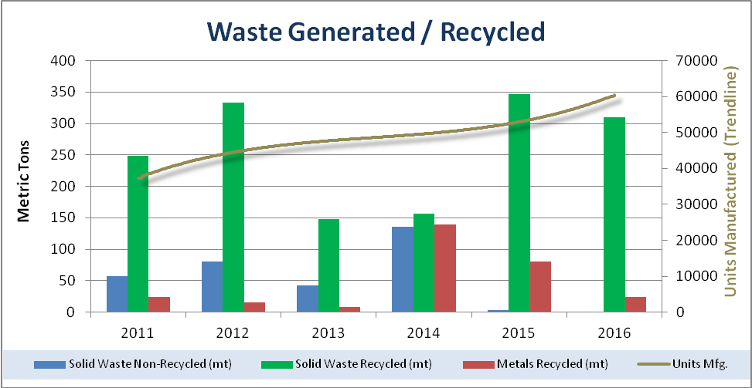

Waste Recycled | 2011 | 2012 | 2013 | 2014 | 2015 | 2016
Solid Waste Non-Recycled (mt) | 57 | 80 | 43 | 136 | 3 | 2
Solid Waste Recycled (mt) | 248 | 333 | 148 | 156 | 347 | 310
Metals Recycled (mt) | 24 | 16 | 8 | 139 | 80 | 24
Units Manufactured | 34419 | 53543 | 40604 | 45328 | 60615 | 57709

Notes:
* Trend line represents finish goods / units manufactured

Summary:
Since 2015 in Pieve di Teco there was an improvement in the production process reducing scrap, then a large part of waste was subjected to several analysis and these allowed us to allocate the greater part of waste to a recycler Supplier.
Since the 2016 starts we have implemented a internal recycle of carton box to create filler and reuse it as packaging material. Supplier pallets are always reused on internal production flow for several cycles

Safety & Health Performance (Pieve di Teco plant)
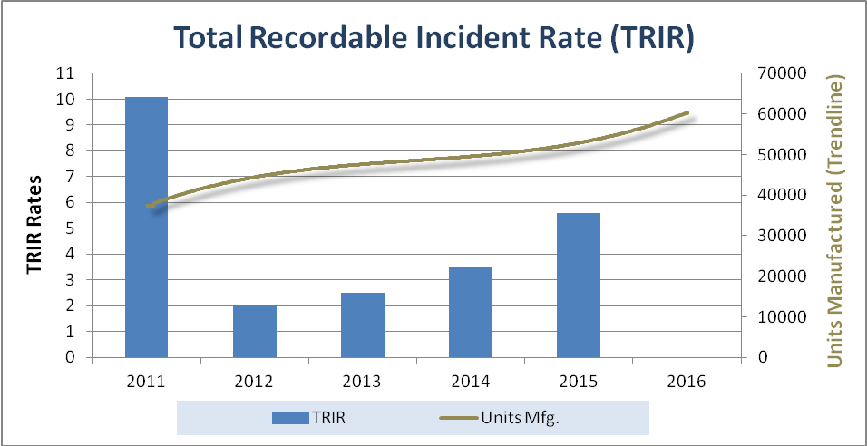

Safety Rates | 2011 | 2012 | 2013 | 2014 | 2015 | 2016
TRIR | 10,1 | 2 | 2,5 | 3,5 | 5,6 | 0
Units Manufactured | 34419 | 53543 | 40604 | 45328 | 60615 | 57709

Notes:
* Trend line represents finish goods / units manufactured

Summary:
In the 2016 we got a great performance because no accidents have occurred. Compared with last years we intensify safety inspections and we have done training focus about prevention program, reporting and safety measures.

