2016 Sustainability Report

Munters Corporation
China，Beijing Factory
No.12 YuHua Roud
China, Beijing

Date: 16 / 02 /2017

“We take our Corporate Social Responsibilities seriously.”

As a global leader in energy efficient air treatment solutions, we at Munters take our Corporate Social Responsibility seriously. We understand how we impact the world we all live in.
This is why at Munters we work every day to create “Your Perfect Climate”. For our customers we provide products and solutions that reduce their energy consumption. This contributes to the reduction of the world’s emissions.
In our manufacturing we have a sustainable approach, focusing on efficient usage of natural resources, while reducing and recycling our waste. Because at Munters, one of our core values is to think “there is always a better way”.
We have made significant improvements but we pledge to always seek opportunities to improve our products as well as our manufacturing practices.
Munters will continue to be a part of creating a sustainable future for everyone.
John-Peter Leesi
CEO, Munters AB

Objectives & Targets Summary

Corporate Objective #1
Implement or refine an Environmental, Health, & Safety Management Program

Target: Refine the current EH&S Program(s) and further integrate into our daily company business management systems
Result: More detailed EH&S Program(s) are integrated into our daily operation actions, such as working protection guideline and Safety inspection system, more practical EHS actions will be done in future.

Corporate Objective #2
Drive continuous improvements through a prioritized EH&S Facility Risk-Aspect List

Target: To assess, select and prioritize our EH&S Risk-Aspects and drive risk reduction within each chosen aspect. Risk reduction shall be measured by the aspect scoring system.

Result: Has accomplished yearly assessment in August of 2016.

Corporate Objective #3
Reduce TRIR Rate by 10% (e.g. outside medical treatment, lost work days, restricted duty)

Target: Reduce our 2016 TRIR Rate from 4.1 to 3.7 by improving our injury root cause analysis process and our corrective actions effectiveness, with emphasis on injury trends.

Result: Actual 2016 TRIR Rate was 3.45, which got the 2016 target 3.7

Corporate Objective #4
Reduce Energy / Resource Use by 6% (e.g. electricity, natural gas, propane, diesel, oil, water)

Target: Reduce electricity use throughout our administration and manufacturing facilities through curtailment practices, more efficient machinery, and refined lighting and HVAC use.

Result: Electricity Energy / Resource Use was increased compared with 2016, which caused by business booming in 2016. Meanwhile,Natural Gas Resource Use were decreased in 2016, the main reason is that blockfoamer was transferred to Jiangyin Factory since August of 2016.

Corporate Objective #5
Reduce Water consumption and/or waste of processes or factory by 6% (reduces, reuse, recycle or capture)

Target: Reduce municipal water use by means of capturing our HVAC condensation water and capturing rain water, for use throughout our manufacturing processes.

Result: Water Resource Use were decreased in 2016, the main reason is that blockfoamer was transferred to Jiangyin Factory since August of 2016.

Corporate Objective #6
Reduce Non-Recycled type waste by 5% (non-recycled wastes, reduce, reuse or recycle)

Target: Redirect our non-recycled wood waste to a wood recycle center. While further reducing wood waste in conjunction with our suppliers, by use of reusable containers.

Result: Waste of processes increased compared with 2015, which caused by business booming in 2016.

Performance Data Summary

Environmental Performance Data
Usage | 2009 | 2010 | 2011 | 2012 | 2013 | 2014 | 2015 | 2016
Electricity (kWh) | 378,800 | 1,028,000 | 894,886 | 884,220 | 815,372 | 860,000 | 1,015,972 | 1,319,460
Natural Gas (therms) | 64,300 | 27,000 | 81,500 | 74,463 | 70,399 | 50,636 | 37,300 | 28,713
Water Usage (mt) | 7,774 | 7,452 | 13,434 | 6,895 | 5,167 | 6,120 | 7,504 | 5,410

Notes:
- Trend line represents finish goods/units manufactured
Summary:
- Electricity Energy / Resource Use was increased compared with 2016, which caused by business booming in 2016.
- Meanwhile,Natural Gas Resource Use were decreased in 2016, the main reason is that blockformer was transferred to Jiangyin Factory since August of 2016.

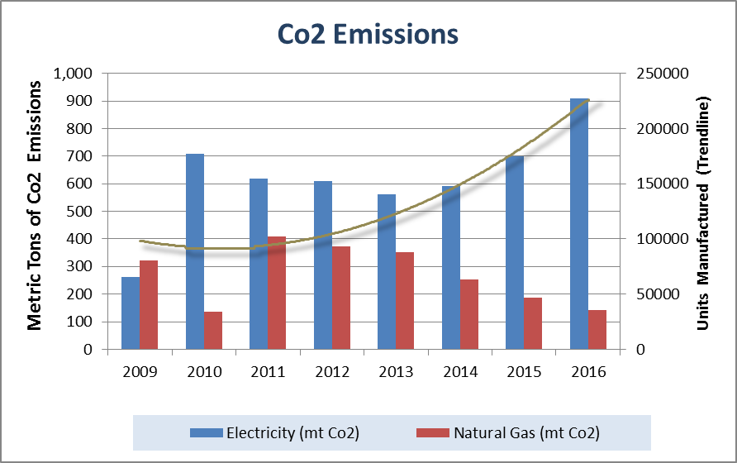
CO2 Emissions | 2009 | 2010 | 2011 | 2012 | 2013 | 2014 | 2015 | 2016
Electricity (mt) | 261 | 709 | 617 | 610 | 562 | 593 | 701 | 910
Natural Gas (mt) | 322 | 135 | 408 | 372 | 352 | 253 | 187 | 144
Total CO2 Emissions (mt) | 583 | 844 | 1,025 | 982 | 914 | 846 | 888 | 1054

Notes:
- Trend line represents finish goods/units manufactured
- All emissions calculated through EPA’s emission calculator (mt/co2) http://www.epa.gov/cleanenergy/energy-resources/calculator.html
Summary:
- Electricity Energy / Resource Use was increased compared with 2015, which caused by business booming in 2016.
- Meanwhile,Natural Gas Resource Use were decreased in 2016, the main reason is that blockfoamer was transferred to Jiangyin Factory since August of 2016.

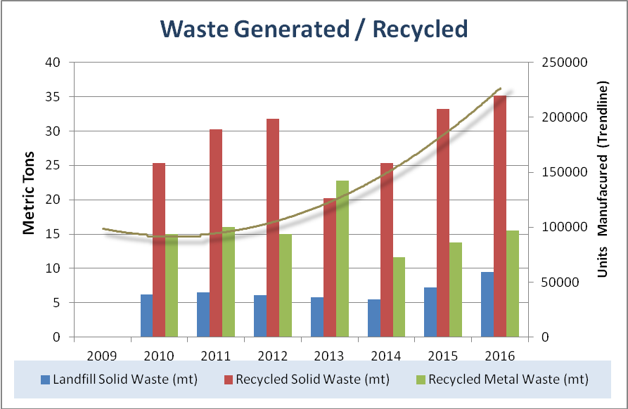

Waste/Recycled | 2009 | 2010 | 2011 | 2012 | 2013 | 2014 | 2015 | 2016
Solid Waste to Landfill (mt) |  | 6.2 | 6.5 | 6.1 | 5.8 | 5.5 | 7.2 | 9.5
Solid Waste Recycled (mt) |  | 25.303 | 30.252 | 31.806 | 21.189 | 25.354 | 33.225 | 35.136
Metals Recycled (mt) |  | 15 | 16 | 15 | 22.747 | 11.606 | 13.764 | 15.471

Notes:
- Trend line represents finish goods/units manufactured
- All data is raw, not normalized; therefore increases are due to throughput increases unless otherwise noted.
Summary:
- Waste and Resource Use was increased compared with 2015, which caused by business booming in 2016.

Safety & Health Performance
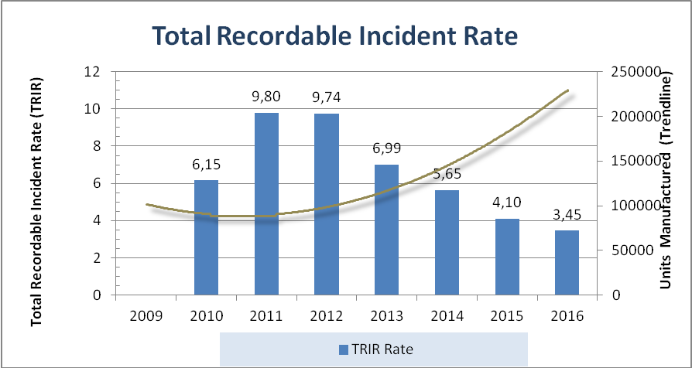

Safety Rates | 2010 | 2011 | 2012 | 2013 | 2014 | 2015 | 2016
TRIR | 6.15 | 9.80 | 9.74 | 6.99 | 5.65 | 4.1 | 3.45

Notes:
- TRIR formula: (Recordable Injuries X 200,000 / Total Labor Hours)
- Trend line represents finish goods / units manufactured.

Summary:
- The EHS development & training in 2016 helped us continuously reduce the risks and physically hurts to workers.

