“It’s all about Cow Comfort”
The progressive dairymen have recognized the critical nature of genetics and feed as keys to maximizing production for many years but have only recently begun to understand how much cow comfort effects productivity. A well designed cross ventilated and evaporative cooled free-stall barn has many benefits and producers are reaping the rewards in higher production and greater efficiencies.
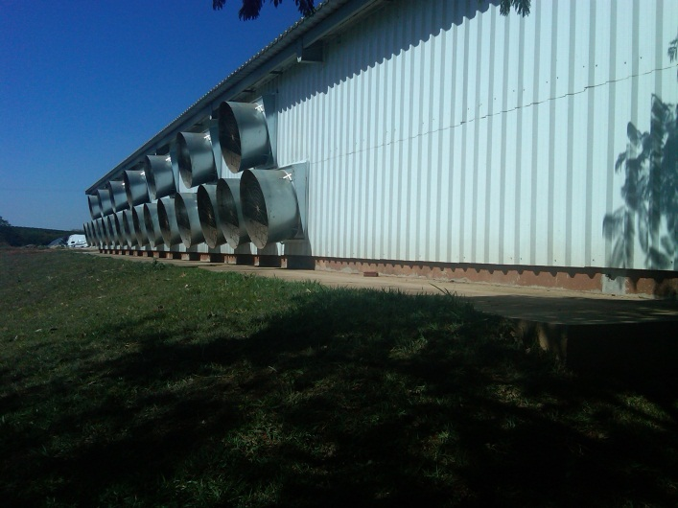The first benefit happens in the construction phase. Cross ventilation allows one wide barn to replace up to four narrow barns, saving space, site costs and construction costs.
This also places the cows closer to the parlor and eases movement of groups to the parlor. It puts cows closer to the maternity areas and the hospital areas for better care.
The well designed cross ventilated barn provides 5 to 6 MPH (2.2 to 2.7 m/s) breeze across the backs of the cows. It also makes it easy to add evaporative cooling to the system. Even in the upper Midwest of the USA where summer days can be not only hot but also humid, evaporative cooling can lower the ambient temperature 12°F (7°C) or more on the typical 90°F (32°C) day.
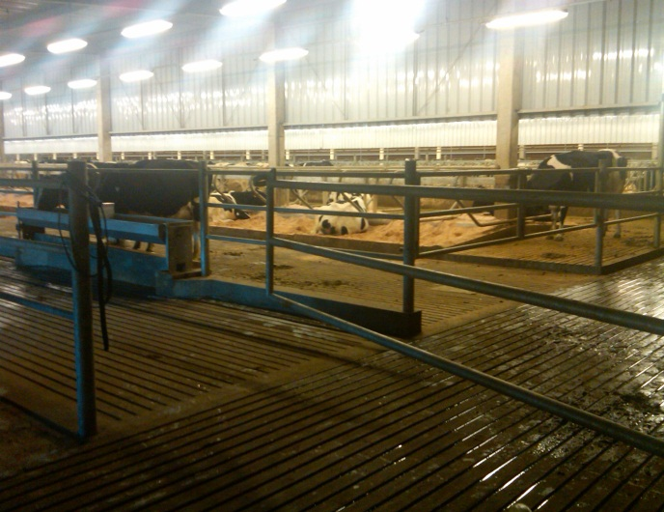Since a dairy cow is most comfortable and productive around 45-47°F (7-8°C) the combination of ventilation and cooling in a closed barn gives the dairyman a combination which leads to several important benefits.
Moving the cooled air rapidly, cow comfort is improved, letting them rest comfortably and lowering their core temperature. The result is higher production and less production dips due to heat stress. Equally important is improved conception rates. Reports of up to a 10% improvement are common which means more cows higher in the production curve. Additional benefits are these barns are warmer in cold weather and are easily controlled with a single environmental controller.
It really is as simple as comfortable cows are less stressed and produce more milk.
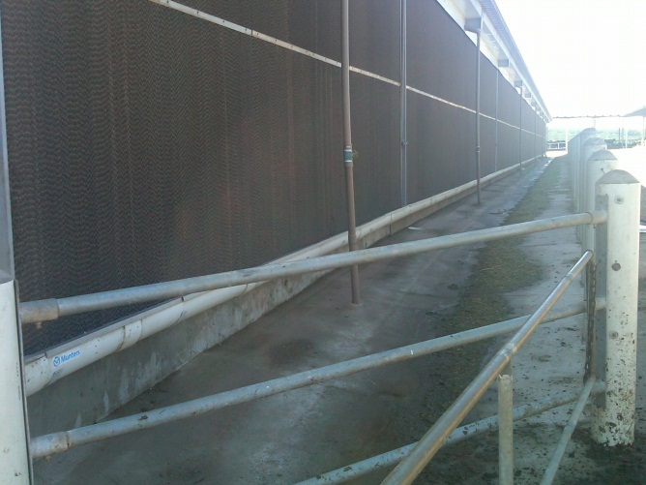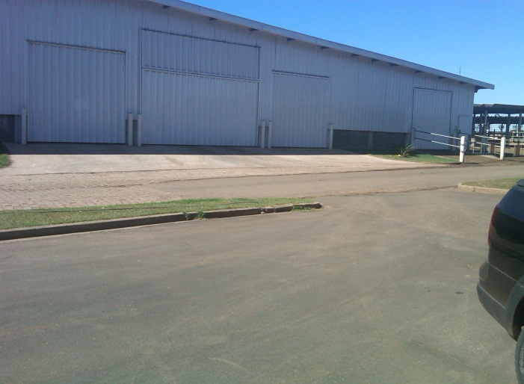
Munters AgHort is
the world leader in
design and installation
of Evaporative Cooled and
Cross or Tunnel Ventilation
for dairy operations.
Munters Corporation 4215 Legion Drive Mason, MI 48854 1-800-227-2376 www.aghort.com

